**System Security**

Go through past year paper

**PART A**

need to elaborate more, e.g. execution method, how it spreads, definition.2) need to elaborate more, e.g. execution method, how it spreads, definition.

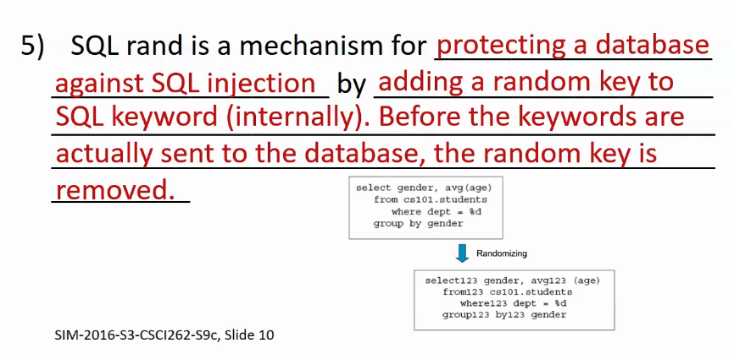

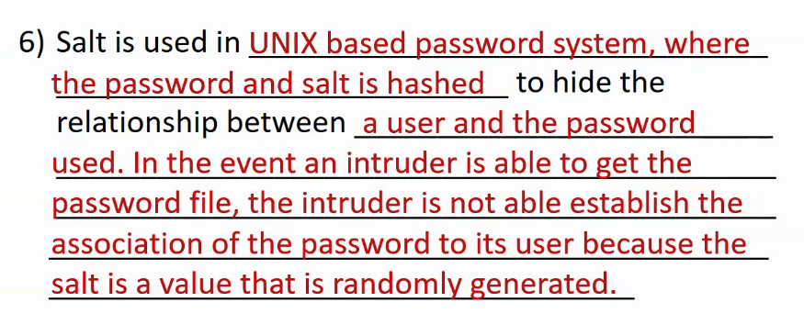

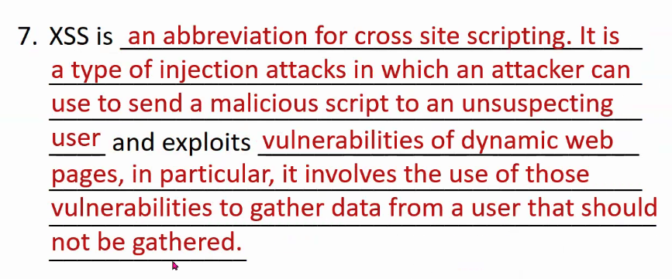

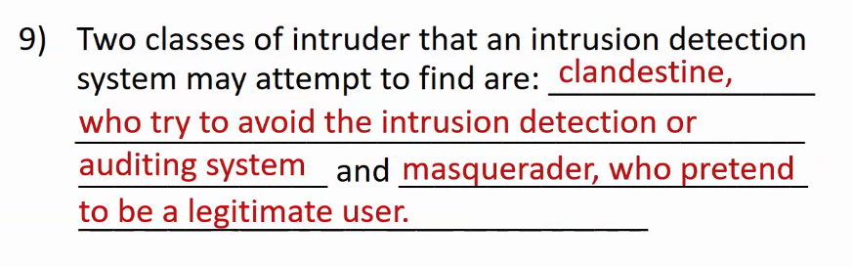

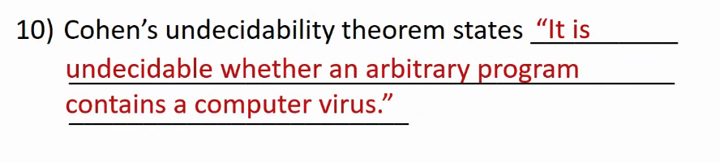

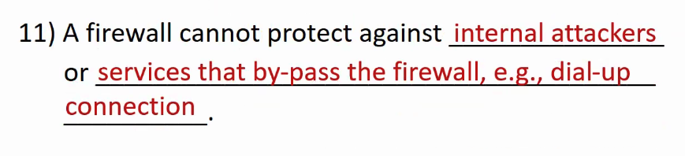

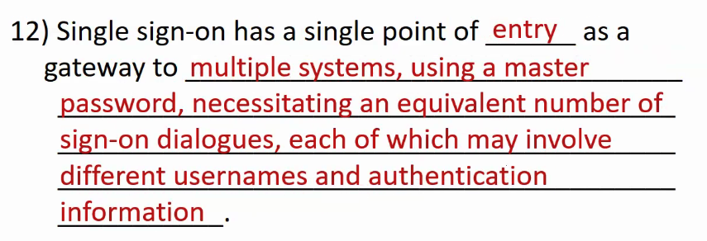

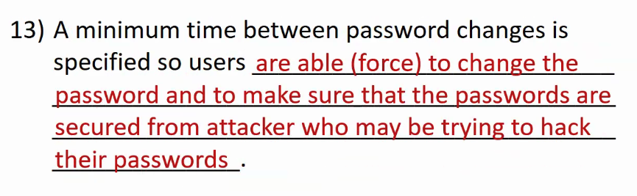

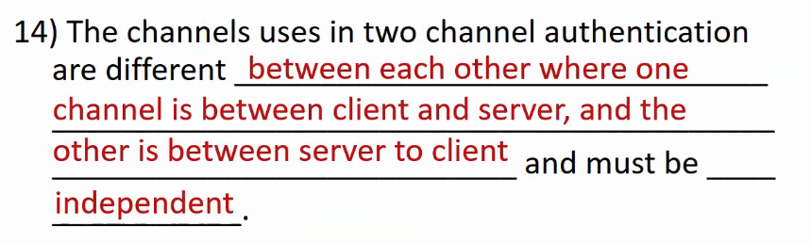

Two channel authentication is definitely two factor authentication but two factor authentication is not two channel authentication

4th factor authentication – where you are (e.g SIM attendance taking)

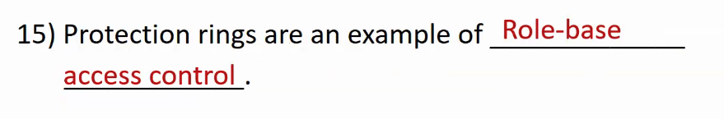

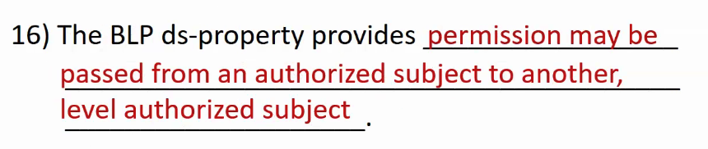

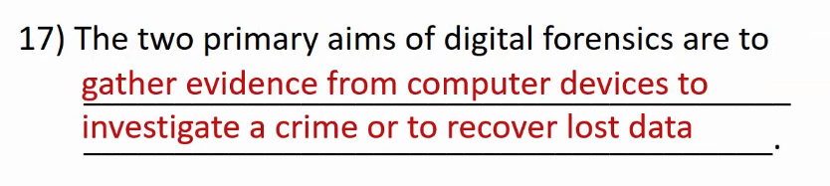

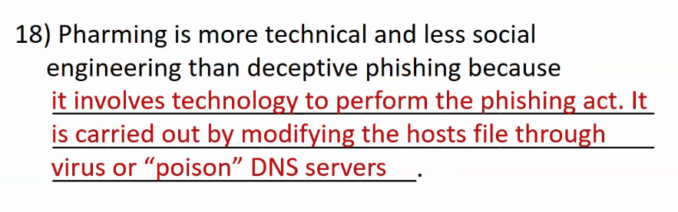

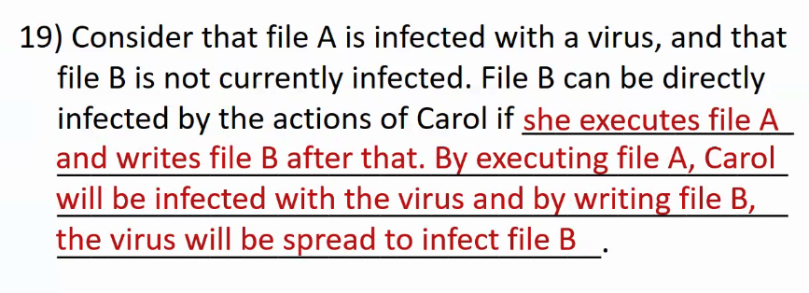

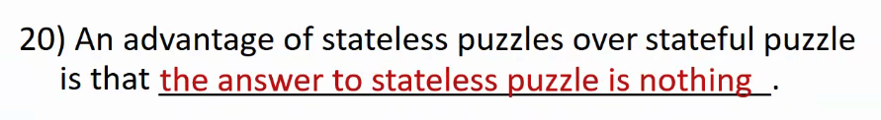

*Refer to tutorial slides for some of the past year paper questions

**PART B**

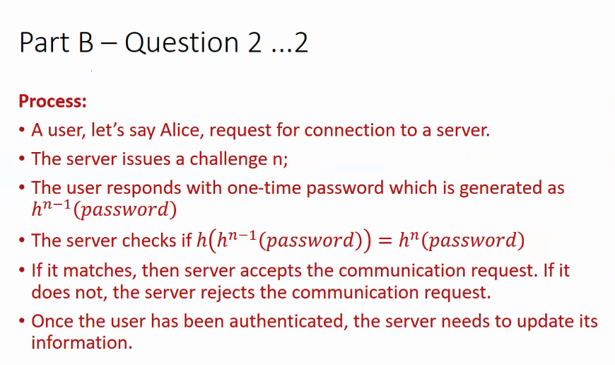

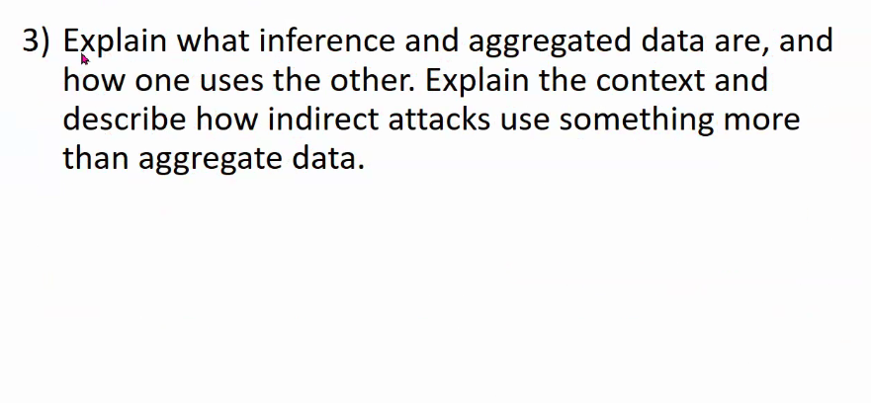

Related to Assignment 3

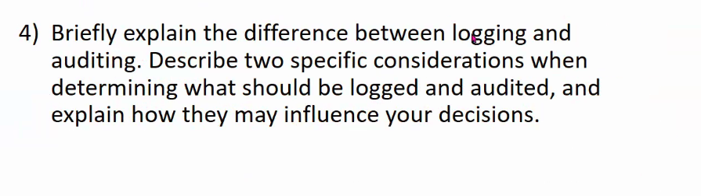

**PART C**

